A Quick Guide to FreeWake20
A more detailed description of the underlying theoretical model with validation and sample applications is listed in “A Higher Order Vortex-Lattice Method with a Force-Free Wake,” by Götz Bramesfeld, Dissertation, Pennsylvania State University, August 2006.
FreeWake2020 is a modification of FreeWake2007/2008/2018/2019. FreeWake20
- has different input and output structures compared to the older versions,
- can model camber lines
- can model junctions with more than two lifting surfaces intersecting (e.g. T-tail)
- can deflect trailing edge flaps
- can trim (pitch and roll so far)
- do alpha and CL based calculations
- model turning flight.
It is meant to work integrated with Vogen.
The program computes the inviscid loads of up to five wings (maybe more). It uses two wake models, one that is prescribed and based on Horstmann’s multiple lifting line method and one that uses a relaxed, force-free wake model. Either model has lifting lines with a spanwise circulation distribution of the shape of a second-order spline.

Input
The default input file is a text file named “input.txt” that is located in the same directory as the executable. The output is written to /output.
A non-default input file is used, e.g. WingC.txt, by calling the program with the executable followed by the root of the non-default input file, e.g. /.fw WingC. The program will create the output subdirectory that has the root of the non-default input file name, e.g. /output/Wing/.

Input File
The lifting surface geometry and flow conditions are defined in the input file
Unless a camber line is defined (in /input/camber/) each lifting surface defines the zero-lift plane of the wing that is modelled, similar to a vortex lattice method. Up to five wings can be defined. Each wing consists of one or more panels. Each panel has the same number of chordwise separations (parameter m). The number of spanwise elements can be defined individually for each panel (parameter n). Subsequently, each panel has of mxn elements.
The following signs serve as identifiers in the input file and, thus, should be used carefully: ‘= ‘, ‘:’ and ‘#’. Any further spaces or comments are being ignored.
The general input is:
Relaxed wake (yes 1, no 0): relax= 1 Wake model
steady (1) or unsteady (0): aerodynamics: = 1 if =0 starting vortices in wake Symmetricalgeometry(yes1,no0): sym=1 if=1onlyrightwingneedstobemodelled
Max. number of time steps: Maxtime = 250
your choice
your choice (0ifonlytimestepping)
Width of each time step (sec): Convergencedelta-spanefffic.:
Free Stream Velocity [ft/sec]:Uinf
deltime= 0.2500 deltae =0.0005
Angle of attack [deg]: Sideslip Angle [deg]:
Reference Area: Refernce Span:
alpha beta
= 1 = 10 = 0
S= 39 b= 12
wings panels m
Thus,each timestep the wing progresses by 1x0.25 deltaX<.25 of chord appears sufficient.
what ever the ref. area is, usually projected wing area what ever is chosen, usually the projected span
No. of Wings (max. 5)
No. of panels:
No. of chordwise lifting lines:
Definition of the panel 1:
= 1 = 2 = 1
conventional config. has 2, wing+Htail
as many as needed for geometry/flaps etc. number of chordwise separations of
the lifting surface
panel #:1 number of spanwise elements: n=5 neighboring panels (0 for none) left:0 right:2
xleft yleft zleft chord epsilon Bound.Cond. 0 0 0 4 0 010
xright yright zright chord epsilon Bound.Cond. 0 3. 0 4 0 220
Definition of panel 2:
panel #:2 number of spanwise elements: n=5 neighboring panels (0 for none) left:1 right:0
xleft yleft zleft chord epsilon Bound.Cond. 0 3. 0 4 0 220
xright yright zright chord epsilon Bound.Cond 0 6. 0 1 -3 100

Besides the panel number, the first line lists the number of elements along the span of the panel. In the following line the indices of the neighboring panels are listed. The value ‘0’ indicates that no neighboring panel exists.
As indicated in the sketch, the coordinates of the quarter chord line are defined for the left and right panel edges (looking in direction of flight) as is the chord and the incidence angle (positive epsilon = pitch up) of the respective edges. Thus, twist can be introduced by have different epsilons on either side edge of that particular panel. Keep in mind that this is a flat-plate approach. Therefore, epsilon should align the panel with the zero-lift line of the particular wing section.
‘Bound.Cond.’ defines the boundary conditions at the respective edge of the panel. For example, the boundary condition of a wingtip is ‘100’, which stands for zero circulation, unknown vorticity strength and derivative thereof. The value ‘220’ is used for two neighboring elements (equal circulation and vorticity) and ‘010’ along the symmetry plane (unknown circulation, zero voriticity, unknown vorticity gradient).

Output

Several output files are being produced and written to files that are located in an ‘output’ directory. The important ones are the timestep files, which contain the information of each timestep, and the general result file. The result file holds the results of the multiple lifting line method followed by the results of the relaxed wake method. The multiple lifting line method computes drag in the Trefftz plane and a long the trailing edge. The second method appears to be more stable numerically. The relaxed wake method loads are recorded for each timestep and listed in the table towards the end of the file.

Some general header information:
Chord: chord length of element
eta: halfspan of element
phi: sweep angle
nu: dihedral angle
epsilon: incidence angle
psi: yaw angle

The wake shape is saved every 20th timestep and the very last one. This information can be used to plot the wake shape using ‘Main PlotML’, which creates a Matlab m-file for plotting of the wing and the shed vortex sheet (in white, which can cause visibility issues with newer Matlab versions).
‘Main Velocityfield’ computes the velocities over a user-defined range. These results are written to two different output file, of which one should be usable with TecPlot.

How to compile

- g++ Source/Main_PerfCode2020.cpp -o fw
- the executable is “fw”

Directory Structure
FreeWake20 requires several subdirectories in order to run properly. The input directories (inputs, camber, and airfoils) have to be created by user before running.

Input Files

Input file
- Holds configuration and general information.
- Should be in directory of executable.
- The sample input file models the wing and t-tail configuration

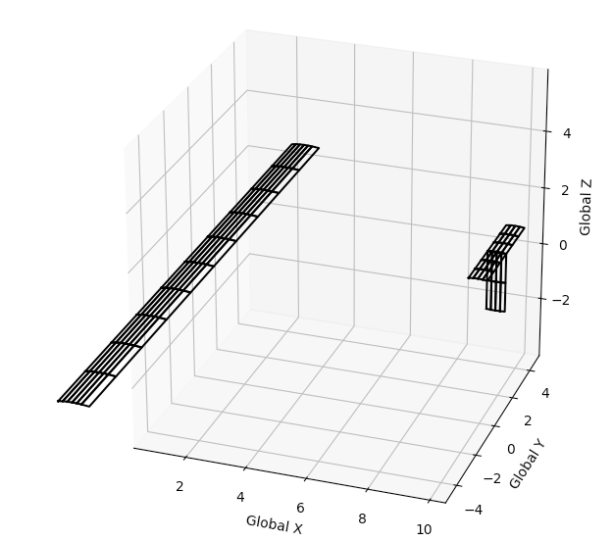

Please note that the program uses equal, number and : signs as special recognizers!
The results are written to the sub-directory output'

Relaxed wake (yes 1, no 0): relax = 0
Steady (1) or unsteady (2): aerodynamics = 1
Viscous solutions (1) or inviscid (0) viscous = 0
Using camber (1) or no camber (0) camber = 1
Symmetrical geometry (yes 1, no 0): sym = 0
Pitch trim (yes 1, no 0): trimPITCH = 0
Roll trim (yes 1, no 0): trimROLL = 0
Lift trim (yes 1, no 0): trimCL = 1

Max. number of time steps: maxtime = 20
Width of each time step (sec): deltime = .5
Convergence delta-span efficiency: deltae = 0.00 (0 if only timestepping)

Freestream velocity (leave value 1): Uinf = 10
AOA beginning, end, step size [deg]: alpha= 15 15 1
Sideslip angle [deg]: beta = 0

Circling flight information
Circling flight on (1) off (0): circling = 0
Turning in horizontal plane (1) horizontal = 0 if (0), a/c descends
Bank angle (deg) phi = 0
Upwind velocity (m/s) Ws = 0
Velocity gradient (1/s) gradient = 0 .00000000001 .3864 .03141592654

Density: density = 1.225
Kinematic viscosity: nu = 1.420000e-05

Reference area: S = 20
Reference span: b = 20

Mean aerodynamic chord: cmac = 1
Aircraft weight (N): W = 3000.0
CG location (x y z): cg = 0.25 0 0
CMo of wing: CMo = 0.00000000

No. of wings (max. 5): wings = 2
No. of panels: panels = 5
No. of airfoils (max. 15): airfoils = 2

Panel boundary conditions:
Symmetry line - 10
Between panels - 220
Free end - 100

Hinge is in percentage chord:
Midchord - 0.5
Leading edge - 0
NO HINGE - 1

Defines leading edge of wing, all measured in metres:

Panel #:1. Number of elements across span n = 5 and chord m = 6
Neighbouring panels (0 for none) left: 0 right: 2
xleft yleft zleft chord epsilon Bound.Cond. Airfoil Hinge Deflection
0.0 -10 0.00 1.00 0.00 100 6 0.75 0
xright yright zright chord epsilon Bound.Cond. Airfoil Hinge Deflection
0.0 0 0.000 1. 0.000 220 6 0.75 0

Panel #:2. Number of elements across span n = 5 and chord m = 6
Neighbouring panels (0 for none) left: 1 right: 3
xleft yleft zleft chord epsilon Bound.Cond. Airfoil Hinge Deflection
0.0 -0 0.00 1.00 0.00 220 6 0.75 0
xright yright zright chord epsilon Bound.Cond. Airfoil Hinge Deflection
0.0 10 0.000 1. 0.000 100 6 0.75 0

Panel #:3. Number of elements across span n = 3 and chord m = 4
Neighbouring panels (0 for none) left: 0 right: 4
xleft yleft zleft chord epsilon Bound.Cond. Airfoil Hinge Deflection
10.15 -2.00 2.00 0.600 .00 100 6 0.75 0
xleft yleft zleft chord epsilon Bound.Cond. Airfoil Hinge Deflection
10.15 .00 2.00 0.600 .00 220 6 0.75 0

Panel #:4. Number of elements across span n = 3 and chord m = 4
Neighbouring panels (0 for none) left: 3 right: 0
xleft yleft zleft chord epsilon Bound.Cond. Airfoil Hinge Deflection
10.15 .00 2.00 0.600 .00 220 6 0.75 0
xleft yleft zleft chord epsilon Bound.Cond. Airfoil Hinge Deflection
10.15 2.00 2.00 0.600 .00 100 6 0.75 0

Panel #:5. Number of elements across span n = 2 and chord m = 4
Neighbouring panels (0 for none) left: 0 right: 4
xleft yleft zleft chord epsilon Bound.Cond. Airfoil Hinge Deflection
10.15 .00 .00 0.600 .00 100 6 0.75 0
xleft yleft zleft chord epsilon Bound.Cond. Airfoil Hinge Deflection
10.15 .00 2.00 0.600 .00 220 6 0.75 0

%<- special identifier
Vertical tail information:
Number of panels (max 5) = 0
no. chord area airfoil

Fuselage information:
Number of sections (max 20) = 0
Width of each section = 0.000
Panel where transition occurs = 0
No. Diamter

Interference drag = 0.0%
##############

